https://www.hackerrank.com/challenges/for-loop-in-c/problem
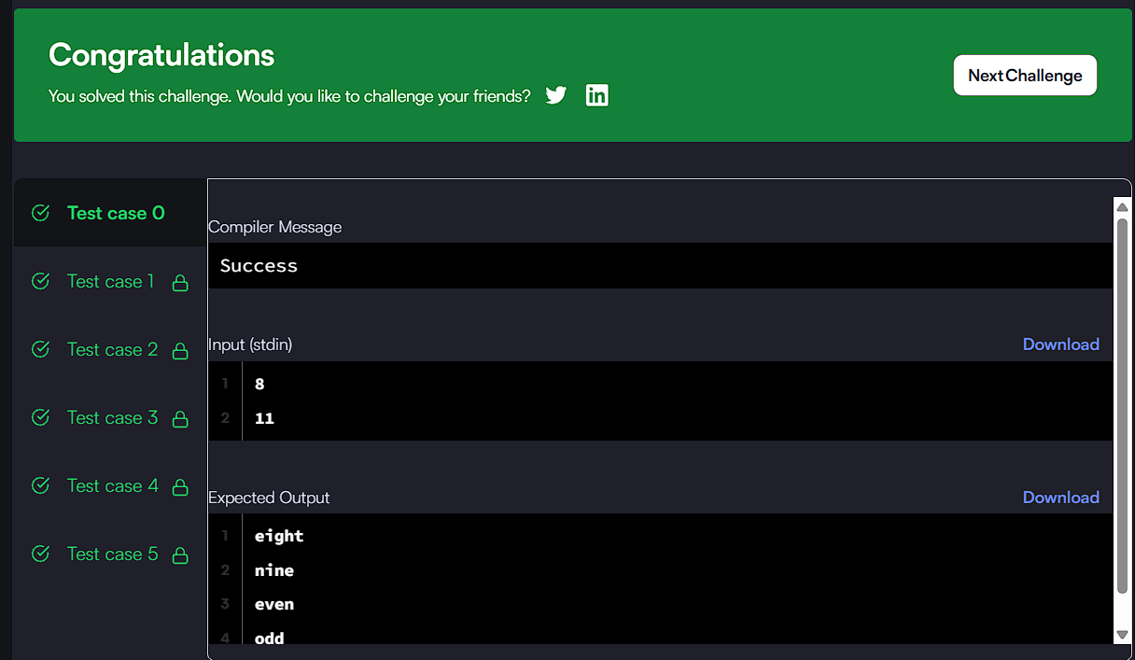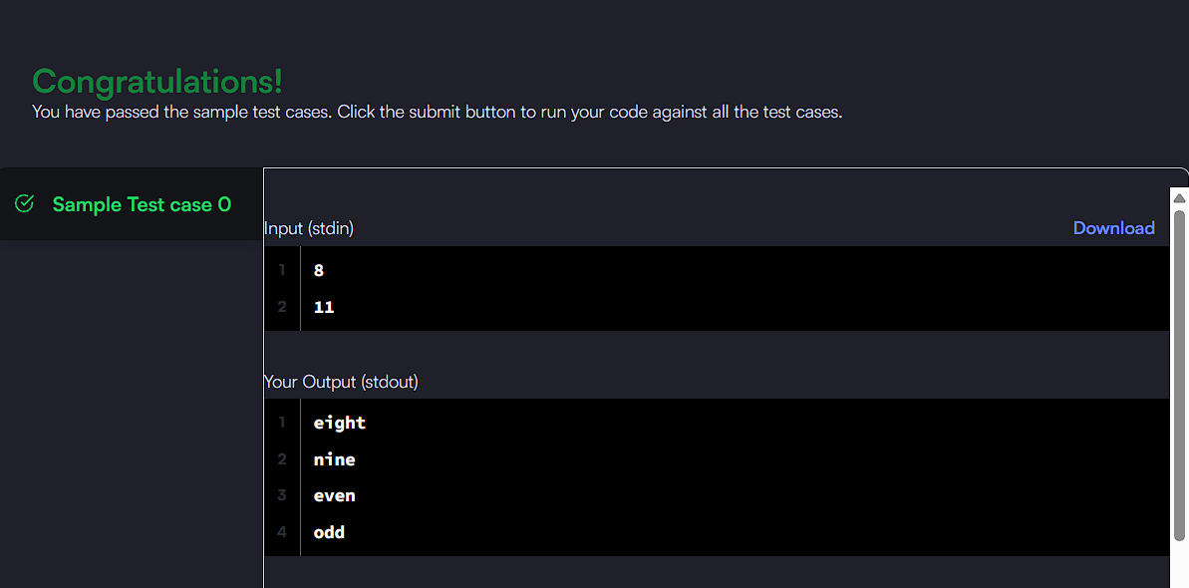

CODE:

const char *names[] = {"", "one", "two", "three", "four", "five", "six", "seven", "eight", "nine"};

for (int n = a; n <= b; n++) {
if (n <= 9) {
printf("%s\n", names[n]);
} else if (n % 2 == 0) {
printf("even\n");
} else {
printf("odd\n");
}
}

